Pergunta 1

Write a function mastermind(guesses, codes) to evaluate a single line of a mastermind game.
The function receives two lists of single character strings. Each string can be "b" for blue, "w" for white and "y" for yellow. The first argument is the user guesses list and the second argument is the codes list containing the correct answer. Each guess corresponds to the correct key in the same position, so the first element of the guesses list corresponds to the first element in the correct list and so forth. Both list arguments have the same length, but can vary in length between tests.
You should return a pair of integers: the first integer is the number of matches in corresponding position and the second integer is the number of matches in an incorrect position.
Note that one right guess (position or color) counts only once.
Por exemplo:
Teste | Resultado
print(mastermind(["b", "w", "y"], ["b", "w", "y"])) | (3, 0)
print(mastermind(["b", "b", "y"], ["b", "w", "b"])) | (1, 1)
print(mastermind(["b", "w", "y"], ["w", "y", "w"])) | (0, 2)
print(mastermind(["b", "y"], ["y", "b"])) | (0, 2)

Pergunta 2

We want to write a function that helps in producing change in Euro coins for a given money amount. In the Euro denomination there are coins for 2€, 1€, 50c, 20c, 10c, 5c, 2c and 1c. If we want to give change using the least amount of coins, we should always use the largest coin for the amount left. For example, to pay 3.45€ we should use coins 2€, 1€, 20c, 20c (again) and finally 5c.
Write a function change(amount) that receives a certain amount and returns a list with the least number of coins to pay that amount. To avoid round-off errors both the amount and coins are positive integers (the number of cents).
Por exemplo:
Teste | Resultado
print(change(345)) | [200, 100, 20, 20, 5]
print(change(500)) | [200, 200, 100]
print(change(17)) | [10, 5, 2]
print(change(6)) | [5, 1]

PERGUNTA 3
Write a Python function local_minima(alist) that receives a list alist and returns a list with all local minima for each neighborhood of three elements.
For example, if alist=[4, 2, 2, 5, 1], then we have 3 neighborhoods: (i) [4, 2, 2]; (ii) [2, 2, 5]; (iii) [2, 5, 1]. In this case, there is only one local minima: [1].
Notice that 2 is never a local minimum because it has another value equal to it in the neighborhood.
Por exemplo:
Teste | Resultado
print(local_minima([10, 3, 3, 14, 5, 7, 4])) | [3, 5, 4]
print(local_minima([0, 3, 3, 14, 5, 7, 4])) | [0, 3, 5, 4]
print(local_minima([2, 1, 1, 1, 7, 3, 1])) | [1, 1]
print(local_minima([5, 1, 43, 21, 5, 63, 1, 5, 5, 5])) | [1, 1, 5, 5, 1, 1, 1]

Pergunta 4

A magic square is a matrix of n*n integer numbers such that every line, column and two diagonals sum the same value.
Define a function magic(mat) that tests if a matrix mat (represented by a list of lists of integers) is a magic square. The matrix can have any square dimensions n*n such that n>=3. The result returned by the function should be a Boolean value: True if the matrix is a magic square and False otherwise.
Note: Your code must pass all tests (all-or-nothing) to get a grade.
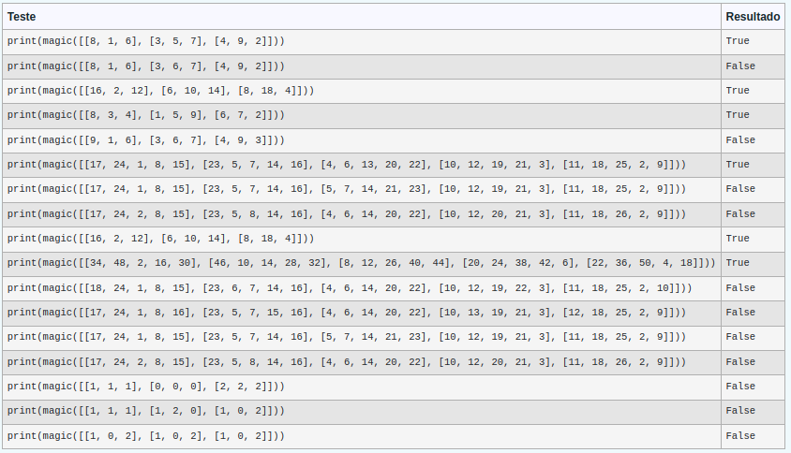

Teste | Resultado
print(magic([[8, 1, 6], [3, 5, 7], [4, 9, 2]])) | True
print(magic([[8, 1, 6], [3, 6, 7], [4, 9, 2]])) | False
print(magic([[16, 2, 12], [6, 10, 14], [8, 18, 4]])) | True
print(magic([[8, 3, 4], [1, 5, 9], [6, 7, 2]])) | True
print(magic([[9, 1, 6], [3, 6, 7], [4, 9, 3]])) | False
print(magic([[17, 24, 1, 8, 15], [23, 5, 7, 14, 16], [4, 6, 13, 20, 22], [10, 12, 19, 21, 3], [11, 18, 25, 2, 9]])) | True
print(magic([[17, 24, 1, 8, 15], [23, 5, 7, 14, 16], [5, 7, 14, 21, 23], [10, 12, 19, 21, 3], [11, 18, 25, 2, 9]])) | False
print(magic([[17, 24, 2, 8, 15], [23, 5, 8, 14, 16], [4, 6, 14, 20, 22], [10, 12, 20, 21, 3], [11, 18, 26, 2, 9]])) | False
print(magic([[16, 2, 12], [6, 10, 14], [8, 18, 4]])) | True
print(magic([[34, 48, 2, 16, 30], [46, 10, 14, 28, 32], [8, 12, 26, 40, 44], [20, 24, 38, 42, 6], [22, 36, 50, 4, 18]])) | True
print(magic([[18, 24, 1, 8, 15], [23, 6, 7, 14, 16], [4, 6, 14, 20, 22], [10, 12, 19, 22, 3], [11, 18, 25, 2, 10]])) | False
print(magic([[17, 24, 1, 8, 16], [23, 5, 7, 15, 16], [4, 6, 14, 20, 22], [10, 13, 19, 21, 3], [12, 18, 25, 2, 9]])) | False
print(magic([[17, 24, 1, 8, 15], [23, 5, 7, 14, 16], [5, 7, 14, 21, 23], [10, 12, 19, 21, 3], [11, 18, 25, 2, 9]])) | False
print(magic([[17, 24, 2, 8, 15], [23, 5, 8, 14, 16], [4, 6, 14, 20, 22], [10, 12, 20, 21, 3], [11, 18, 26, 2, 9]])) | False
print(magic([[1, 1, 1], [0, 0, 0], [2, 2, 2]])) | False
print(magic([[1, 1, 1], [1, 2, 0], [1, 0, 2]])) | False
print(magic([[1, 0, 2], [1, 0, 2], [1, 0, 2]])) | False

Pergunta 5

Write a Python function mult(M, N) that computes the matrix multiplication between the matrices of integers M and N, in that order. When the matrices’ dimensions are not compatible, the function must return an empty list.
You cannot use numpy.
Por exemplo:
Teste | Resultado
print(mult([[1, 2], [3, 4]], [[2, 0], [1, 2]])) | [[4, 4], [10, 8]]
print(mult([[1, 2, 3], [4, 5, 6]], [[9], [8], [7]])) | [[46], [118]]
print(mult([[7, 8, 9, 10]], [[5], [3], [2], [7]])) | [[147]]
print(mult([[1, 2], [3, 4]], [[5], [6], [7]])) | []

